Local DNS Attack Lab

Lab Tasks (Part I): Setting Up a Local DNS Server

Task 1: Configure the User Machine
In this task, we configured the user machine to use our local DNS server. By modifying the /etc/resolv.conf file, we ensured that all DNS queries were directed to our controlled DNS server. This step was crucial as it allowed us to control DNS responses and observe their behavior in later tasks
.
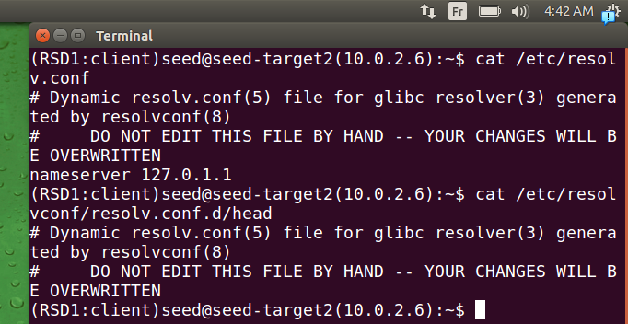
./etc/resolv.conf this file is used to store local dns server addresses, note that 127.0.1.1 is used as local dns caching resolver in memory before going externel I mean
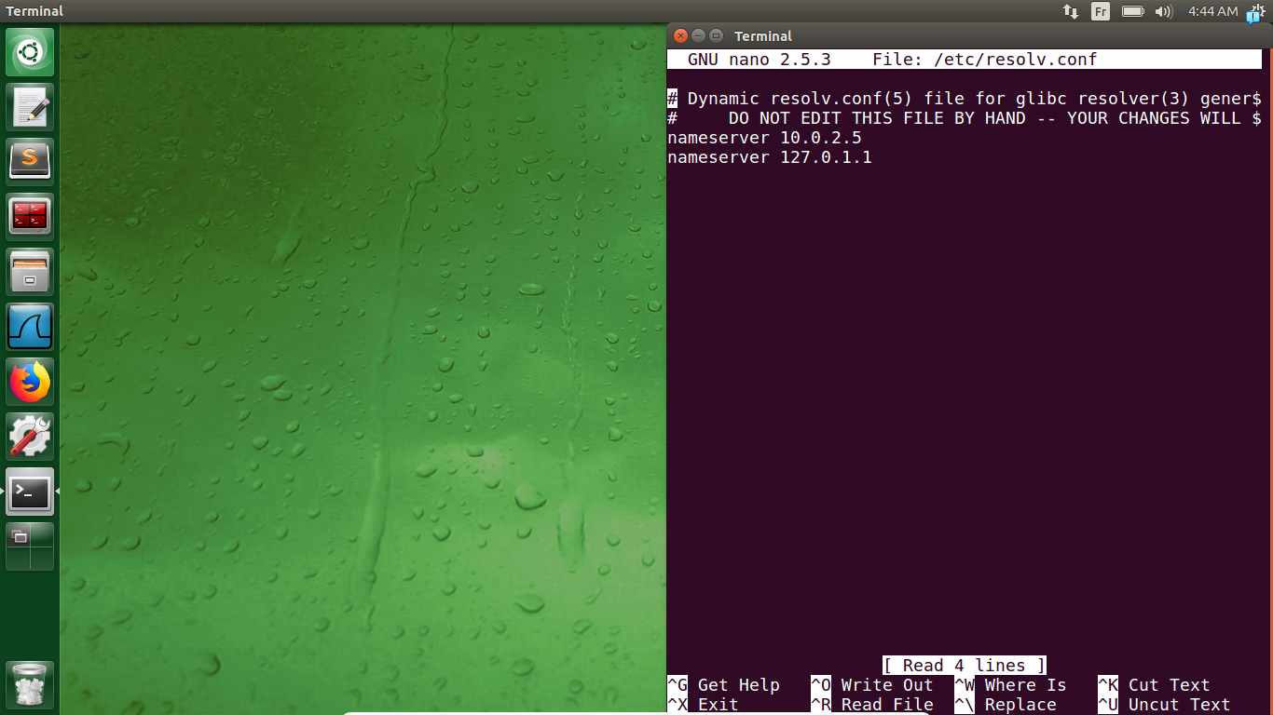
.we add our local dns server address 10.0.2.5
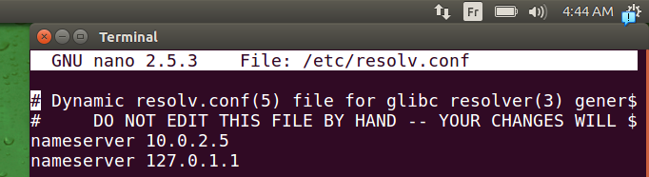
.we can see effect change
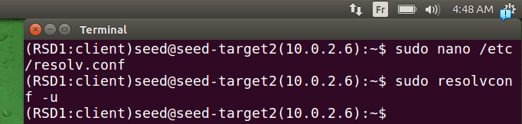
.but if we active it
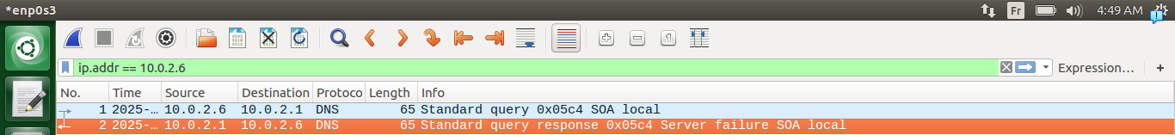
.we can see that the default gateway machine(it’s because of dhcp as mentionned there) has changed it back, we got updates
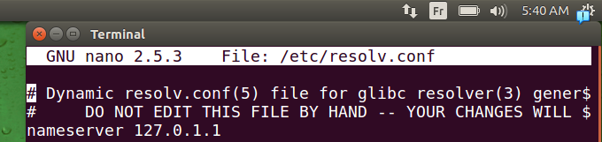
.and it returned back to normal
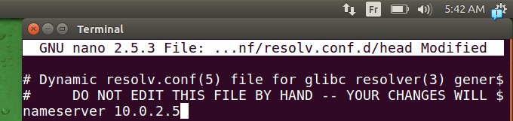
.for this we to not be modified again, we go to the file /etc/resolvconf/resolv.conf.d/head and add our local dns server address, this will add it to our last file each time DHCP tries to update it
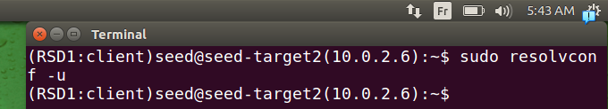
.we apply the modification(apply a new dns configuration settings)
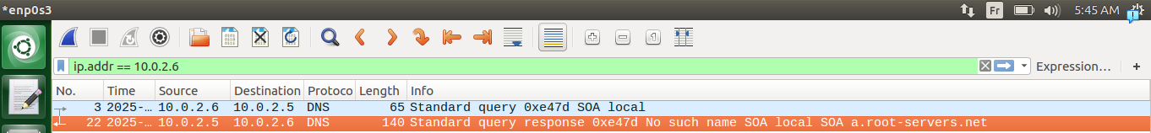
.we can see now that our client machine is querriying the address we appended
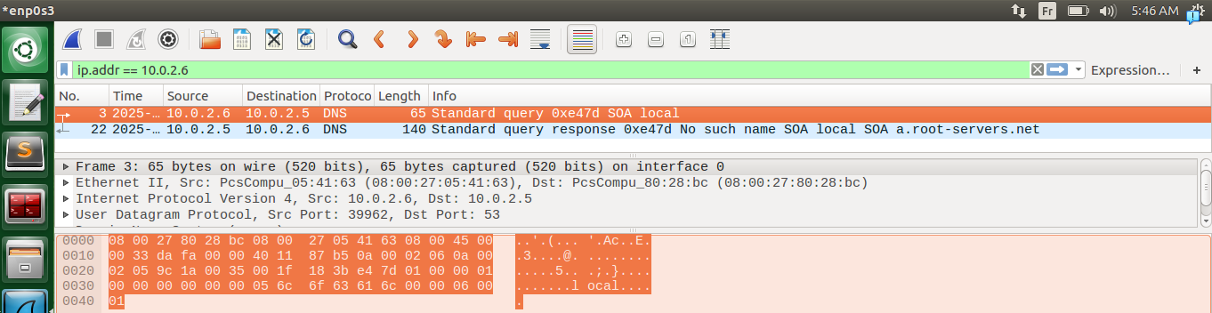
.here as we see it’s asking the address we mentionned
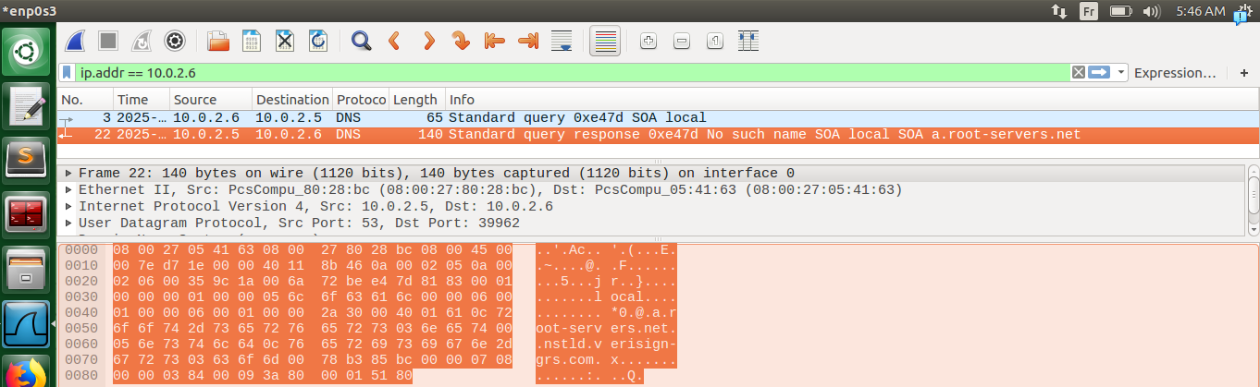
.and the server is responding
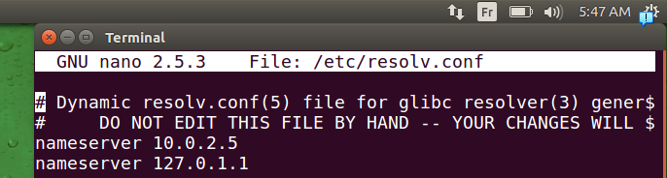
.we can see that now our modification is not changed, permanantely
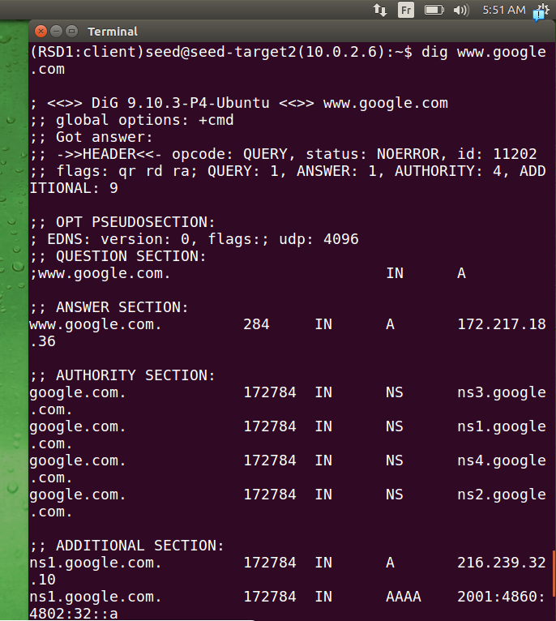
.if we dig google.com
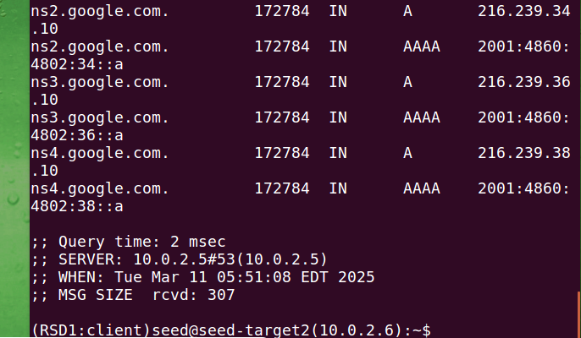
.we can see SERVER: 10.0.2.5 it’s asking the addres of our local dns server as mentionned
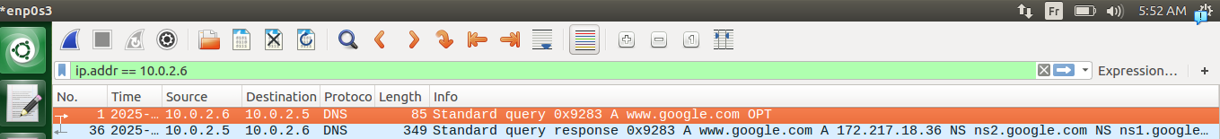
.querry and a response can be seen clearly

Task 2: Set up a Local DNS Server

Step 1: Configure the BIND 9 server.
.
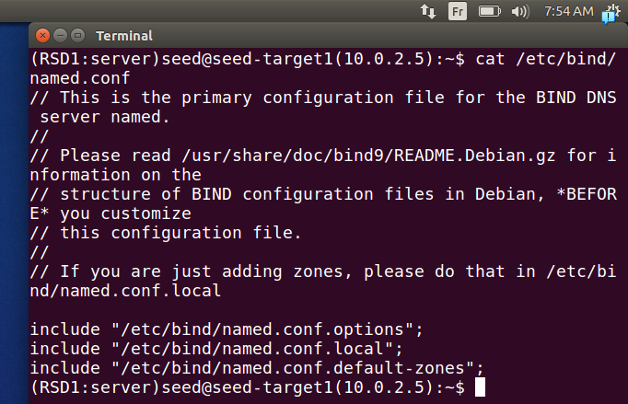
./etc/bind/named.conf is used to define configuration files, and it has the configuration of bind DNS server (it has like here 3 configuration files: general settings, for local domains, and the last for predifinned zones)
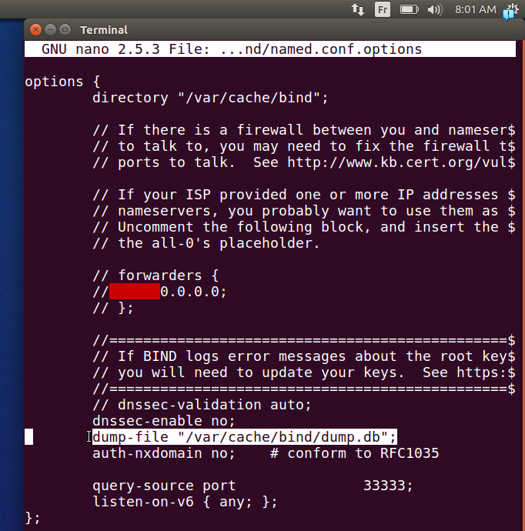
.we are interested in /etc/bind/named.conf.options that contains configuration of the dns local server, like security settings and where to store dns records (cache) …..etc
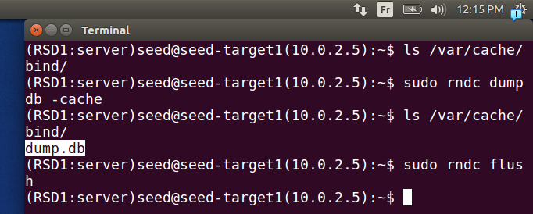
.we have 2 commands one for clearing all dns cache record of bind server (sudo rndc flush)
and the other (sudo rndc dumpdb -cache) is used to dump the current cache records into the file dump.db as mentionned earlier
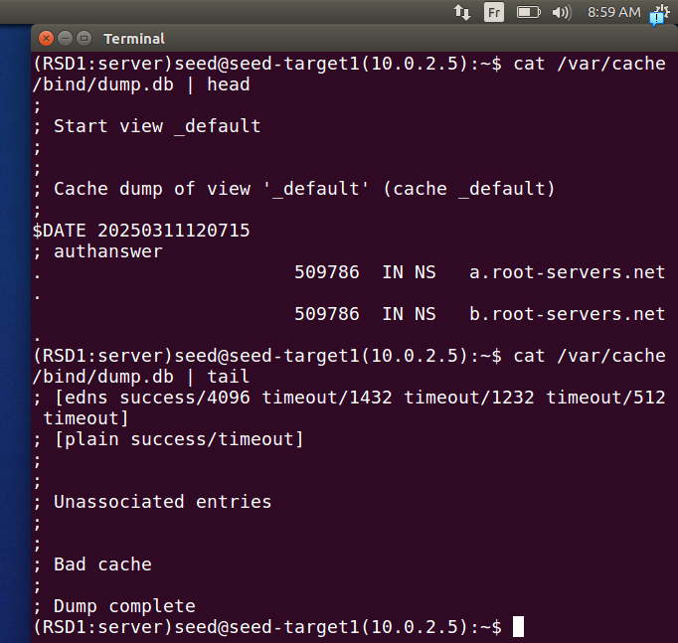
.default content of the file (head, tail) of the file, we can see some authoritative name server

Step 2: Turn off DNSSEC.
.
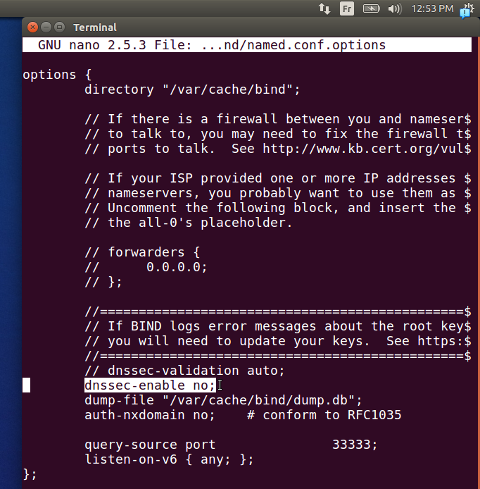
.here we didn’t turn it down but it was by default down,
dnsec is a security mecanisme that uses a public key cryptography to digitally sign dns records, it doesn’t encrypt but verify authenticity

Step 3: Start DNS server.
.
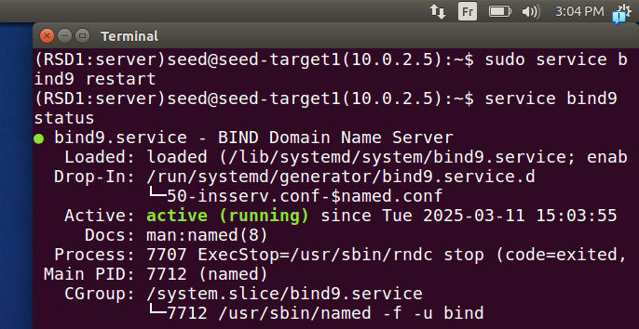
.we restart the service bind responsible for our dns server

Step 4: Use the DNS server.
.
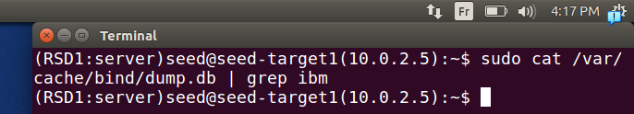
.here as you can see no dns record for ibm
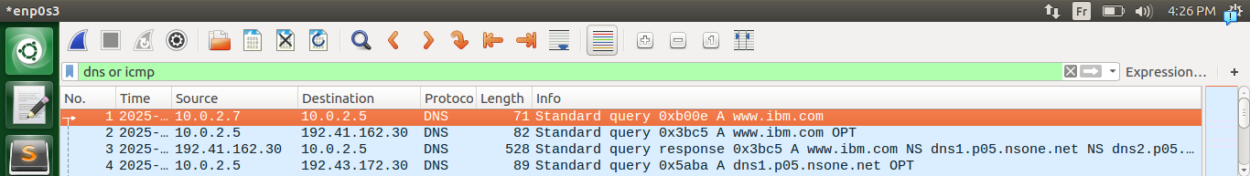
.if we querry from client side we can see our querry going to the dns server
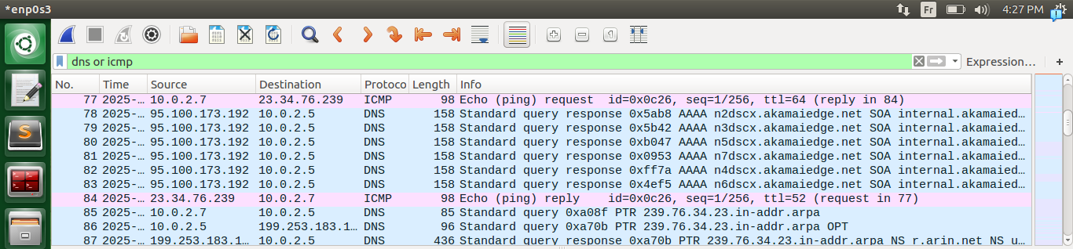
.we can see replies
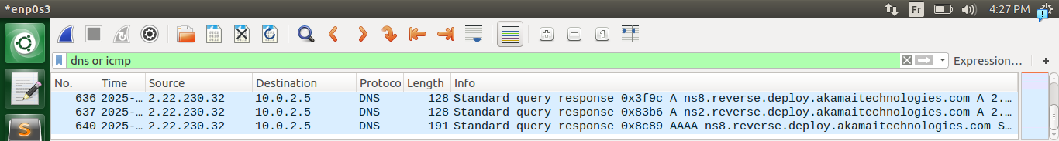
.and even after the reply some querry still gotten into our dns server, like if we got a minimal amount of responses we send them to client
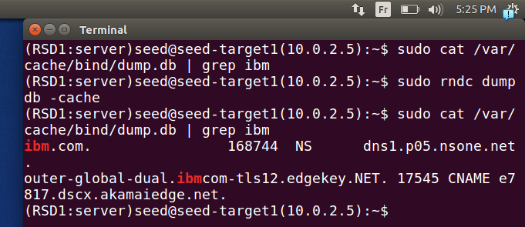
.if dump the the cache we can see a new record apppearing (authoritative one NS)
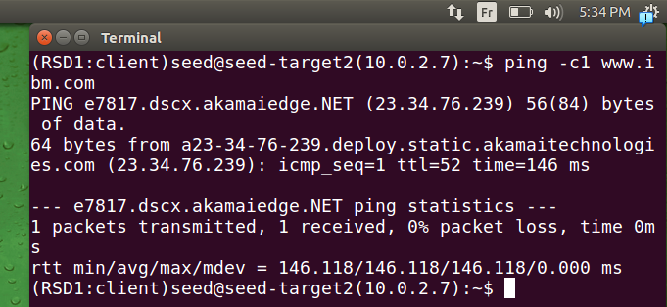
.our ping worked with success
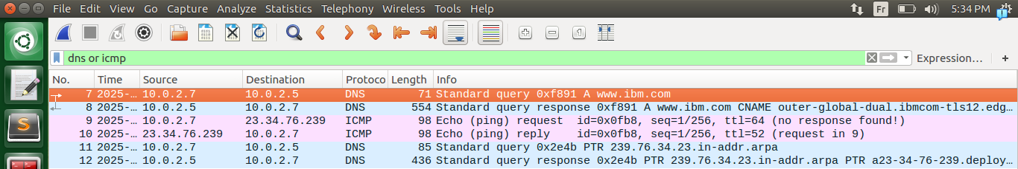
.here the response directly can be seen clearly if we ping another time(it uses it’s cache not asking other servers)
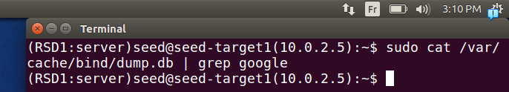
.here we don’t have any dns record for google
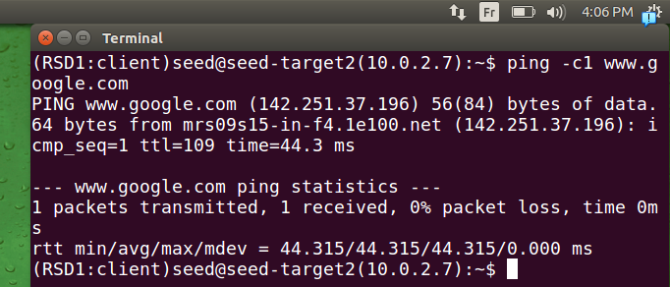
.if we ping it google
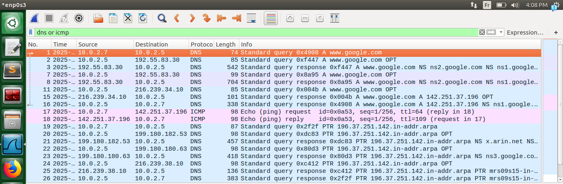
.it starts resolving the ip address note that because google has branches over the world and it’s widely acceed it didn’t take much time
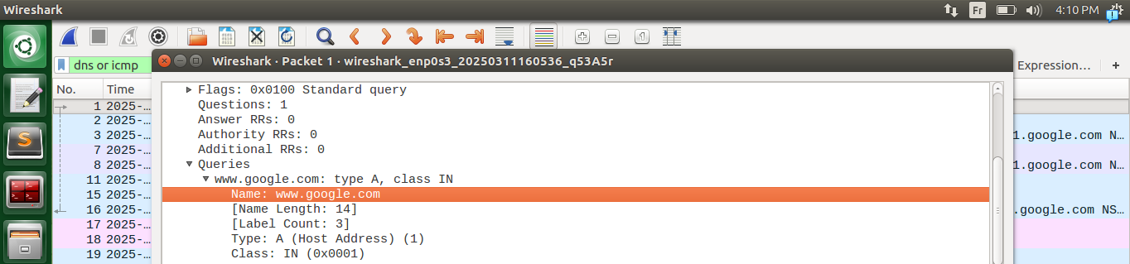
.if we entre the querry we can see in querry section the name we want to resolve
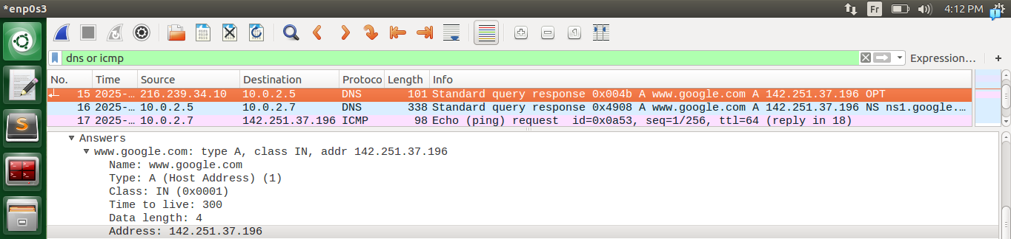
.in this response we got the ip address of the hostname of google wanted by client we will save it in cache and send it to client (it’s in answer section)
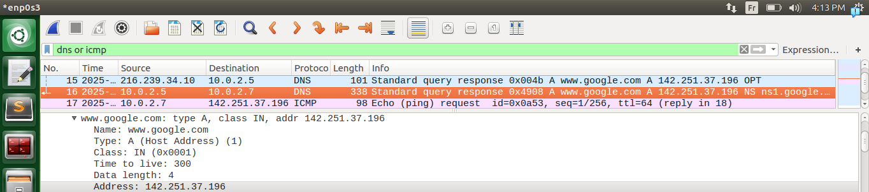
.in answer section the reply from dns local server to client machine
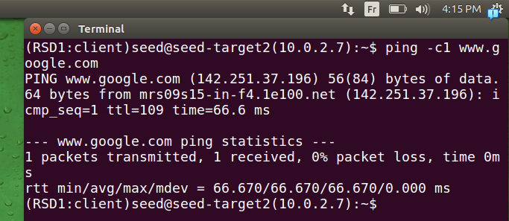
.if we ping again
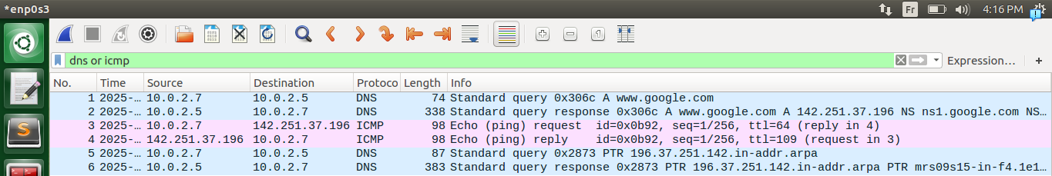
.it’s saved in local dns server cache so it responds directly
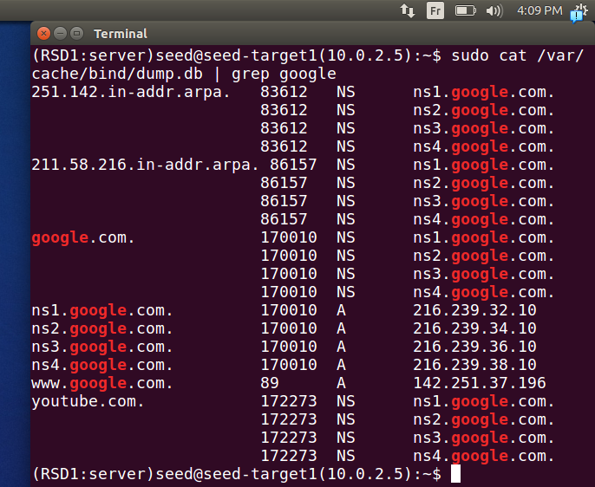
.here we can see the records being saved
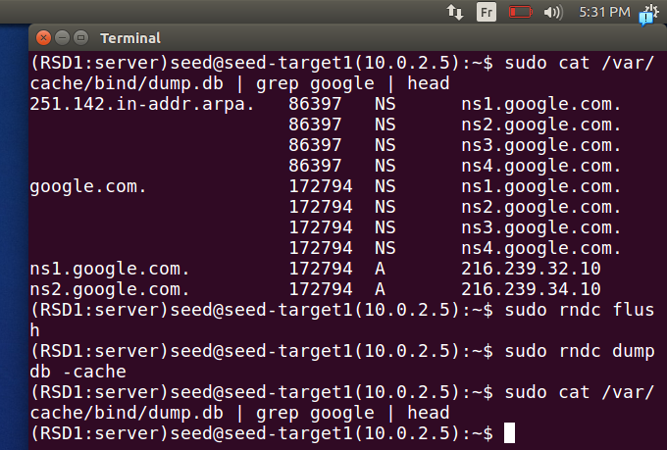
.here if flush and dump no cache recorded can be seen
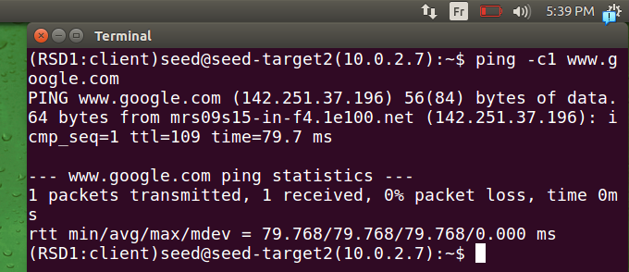
.here if we ping again
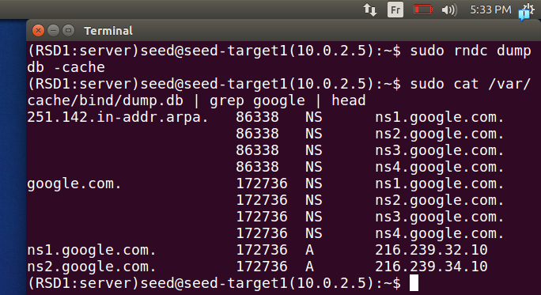
.like we said it’s probably because of braches of google located near we got same reponses

Task 3: Host a Zone in the Local DNS Server

Step 1: Create zones.
.
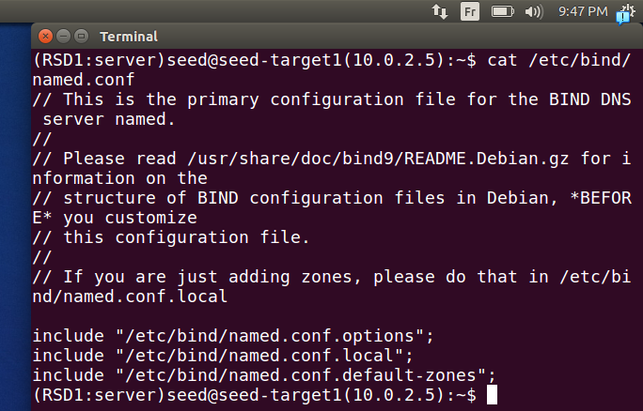
.as me said before this file is used for configuration
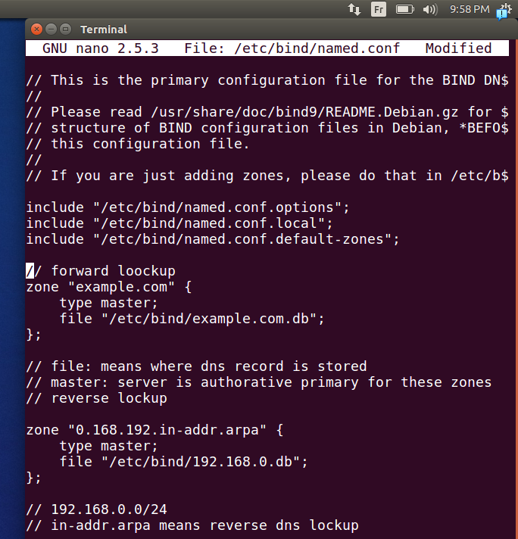
.we add two one for forward and one for reverse lockup(the reverse one is obligatory for some services like mail services)

Step 2: Setup the forward lookup zone file.
.
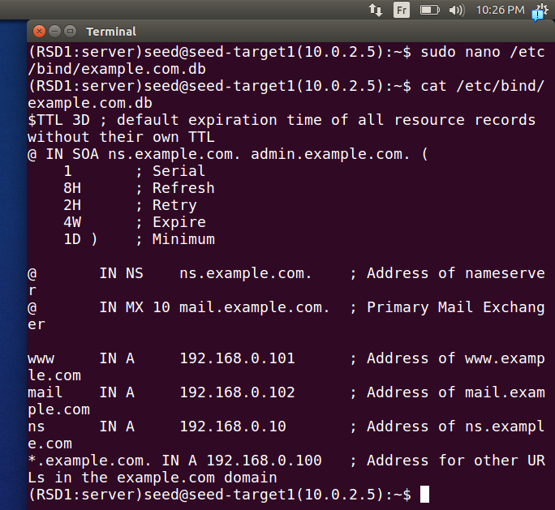
.

Step 3: Set up the reverse lookup zone file.
.
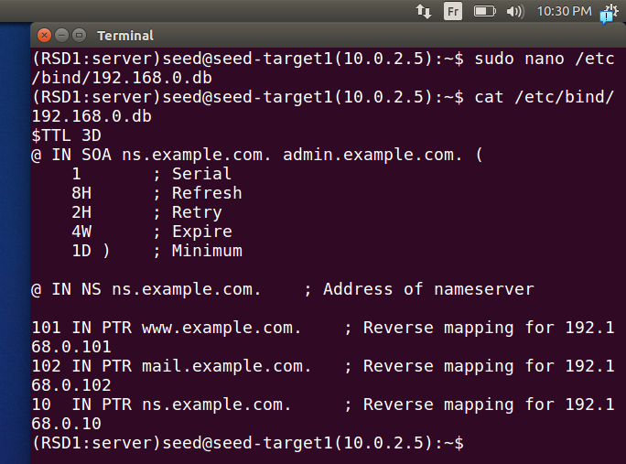
.

Step 4: Restart the BIND server and test.
.
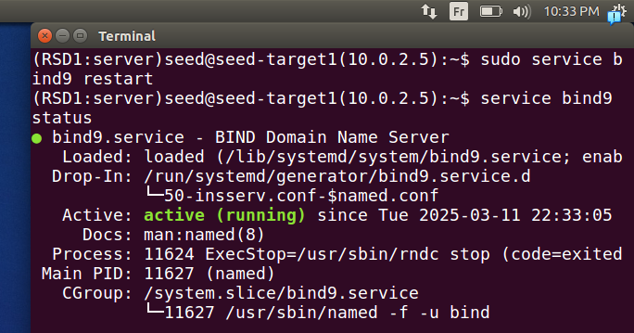
.

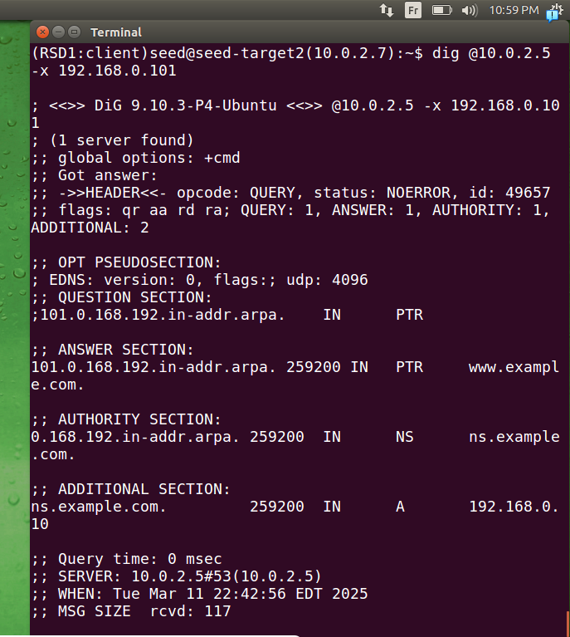
.
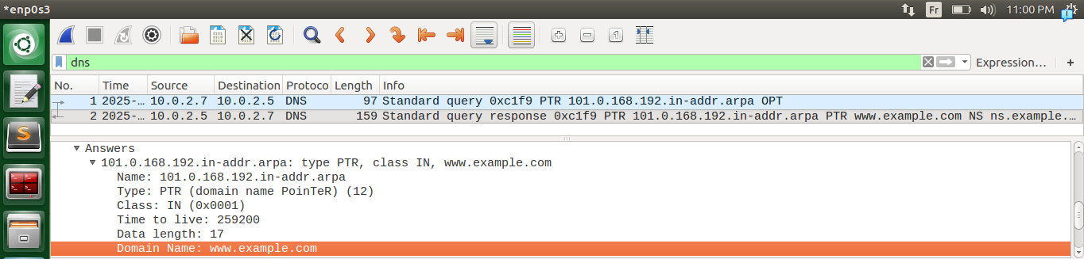
.
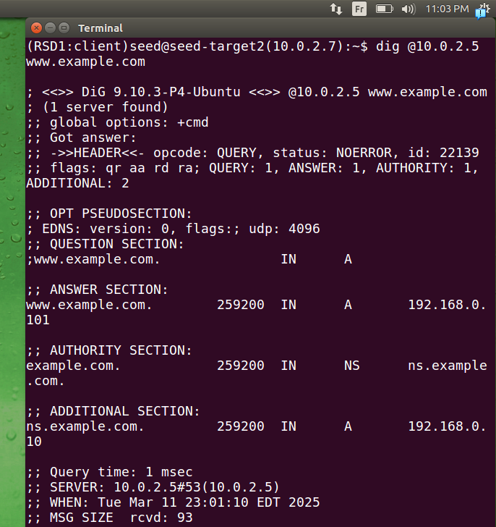
.
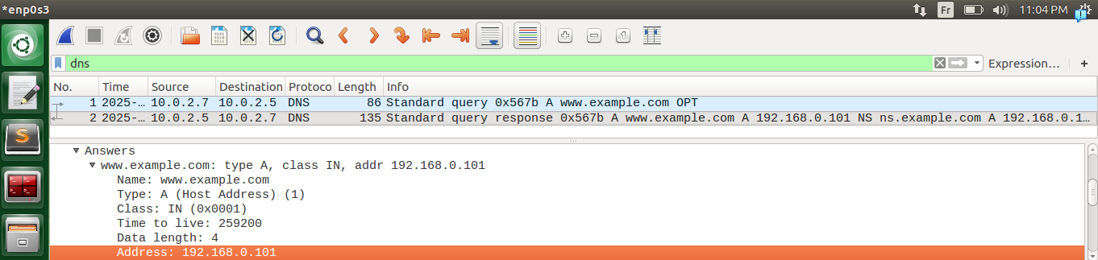

Lab Tasks (Part II): Attacks on DNS

Task 4: Modifying the Host File
.
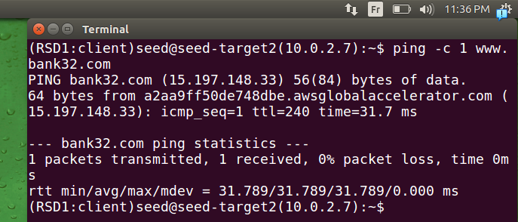
.
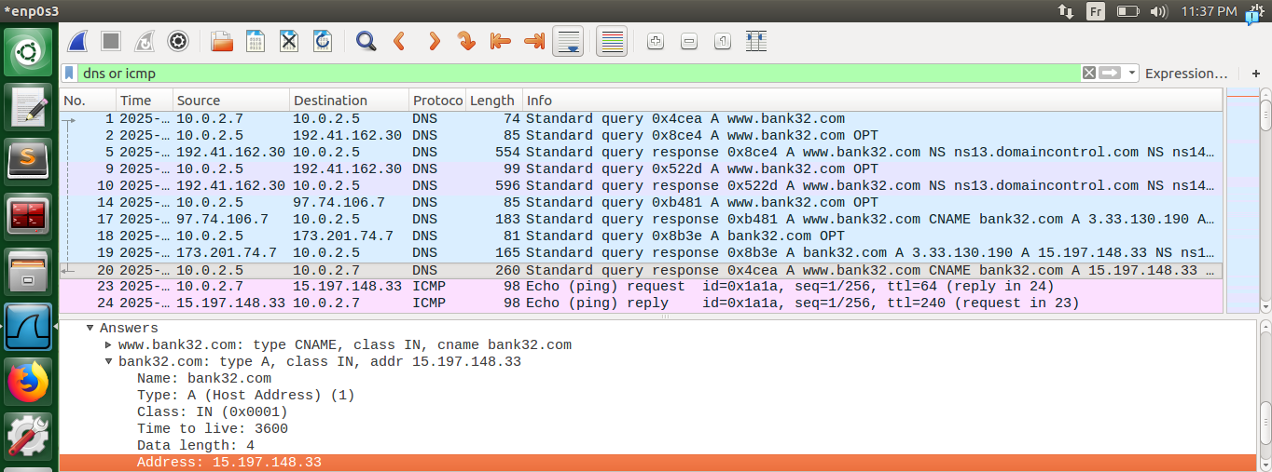
.
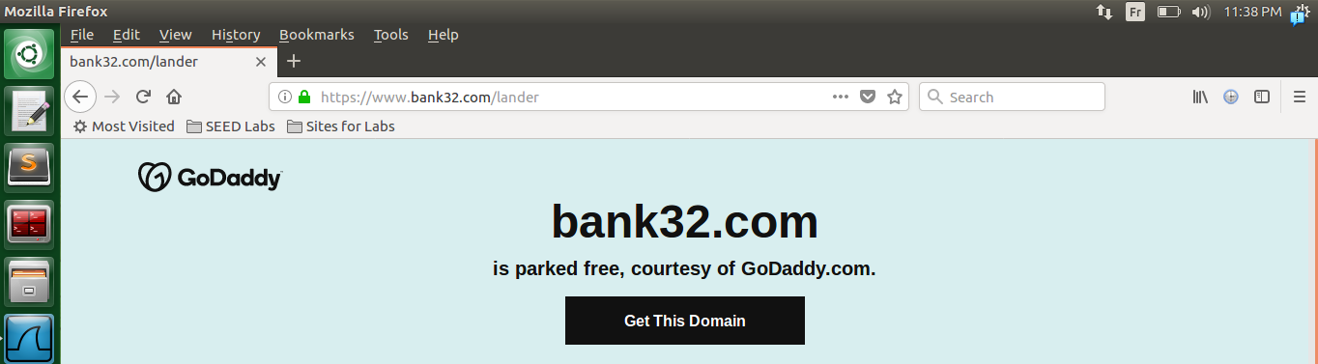
.
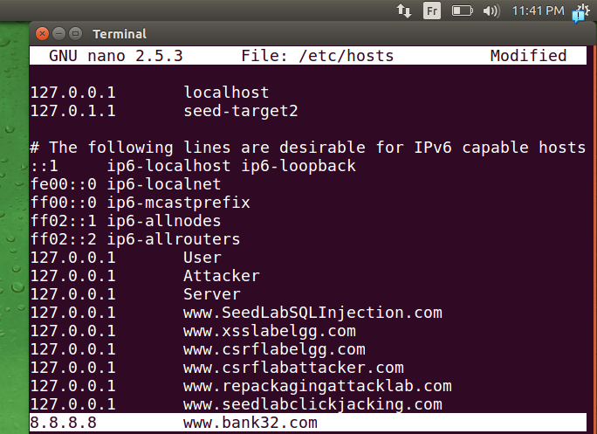
.
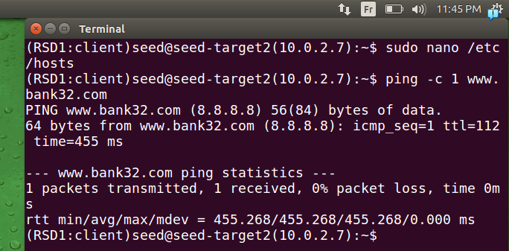
.

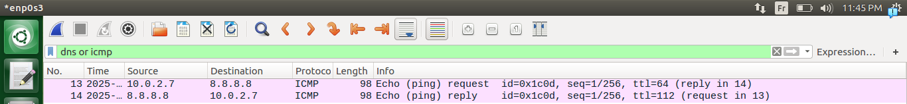
.
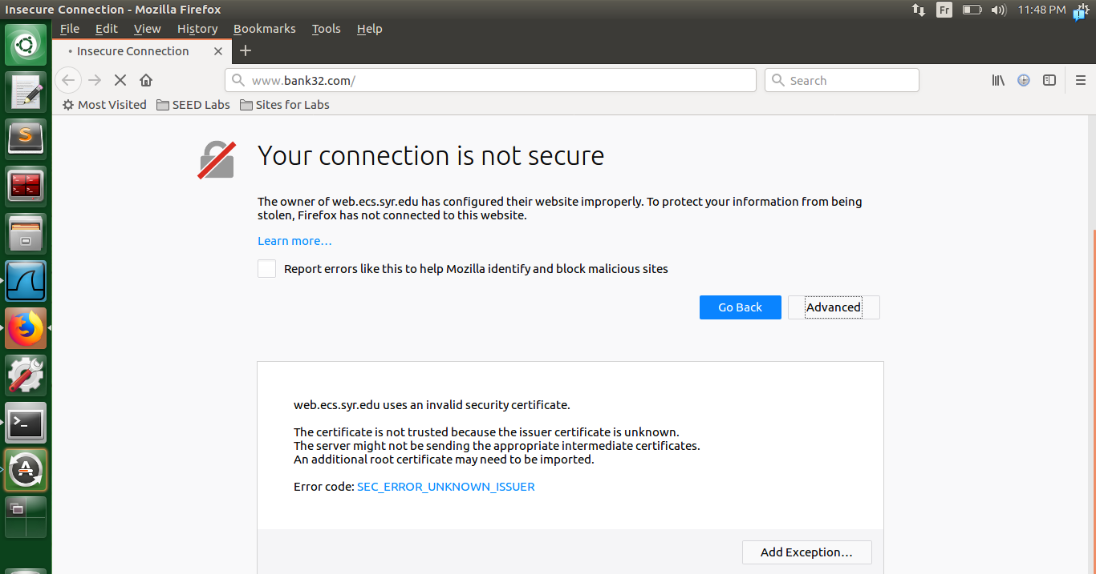

.
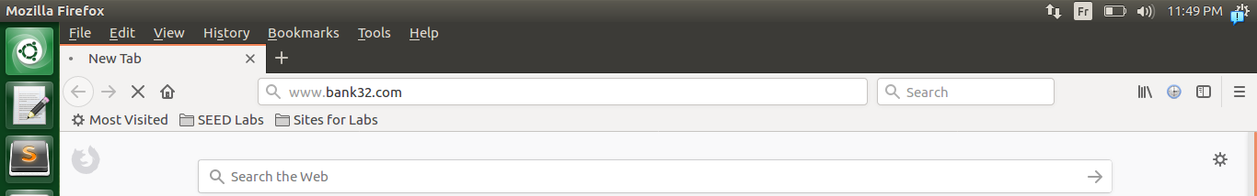
.
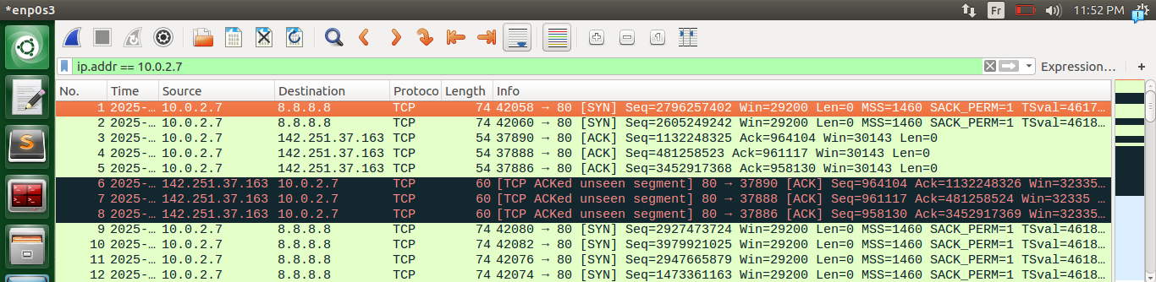
.
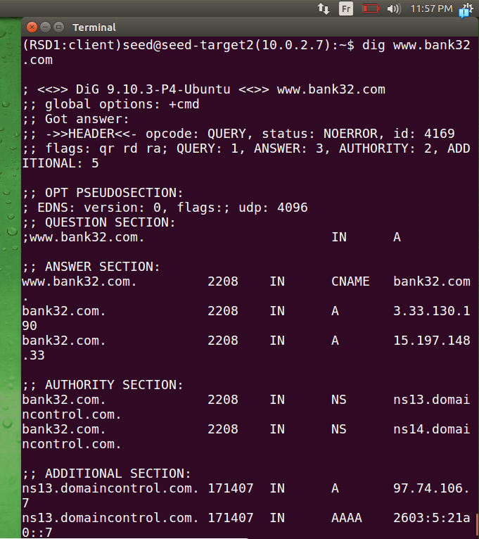
.
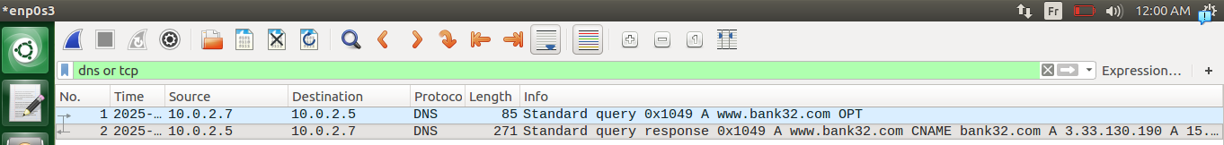
.

Task 5: Directly Spoofing Response to User
.
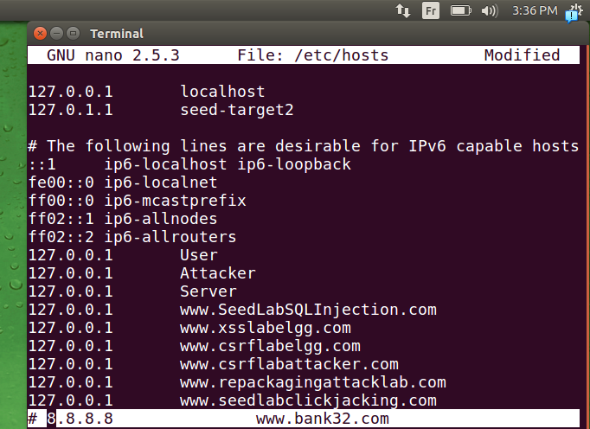
.
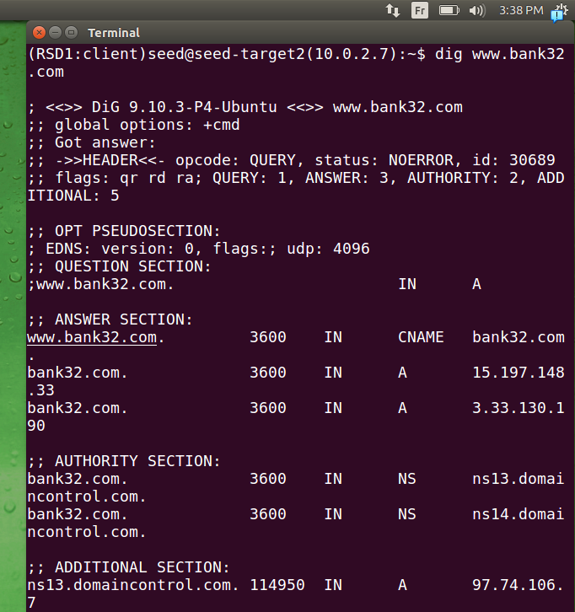
.
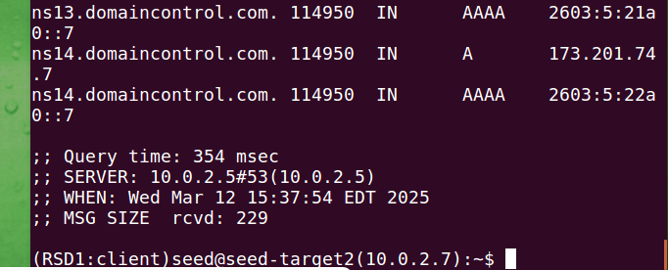
.
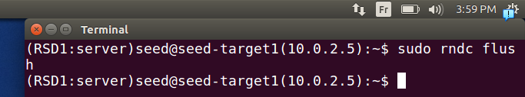
.
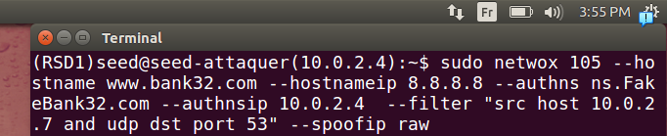
.
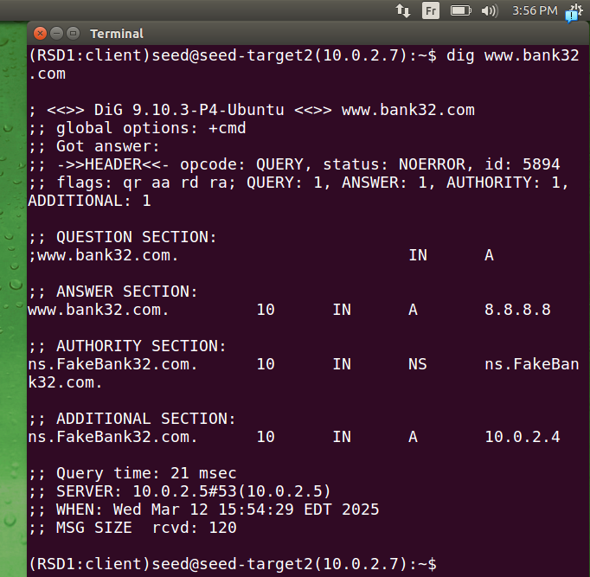
.

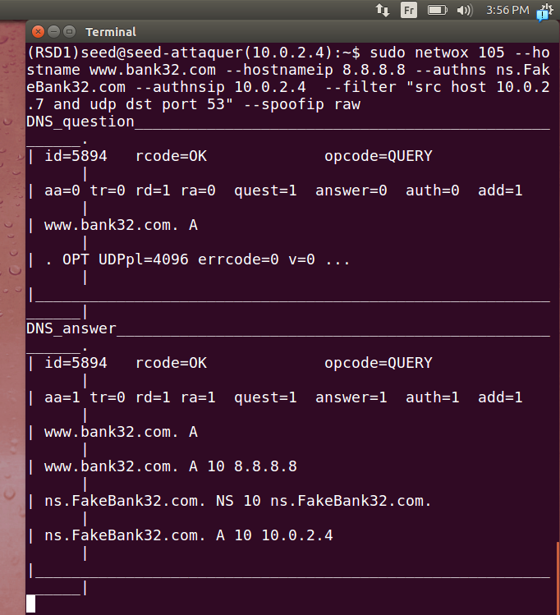

.
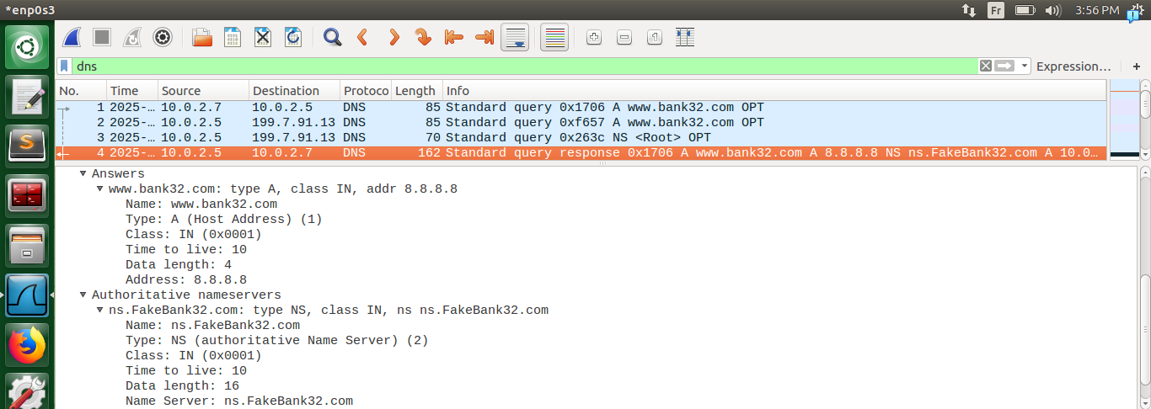
.
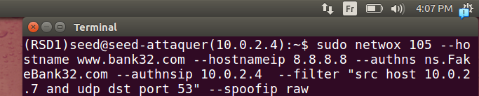
.
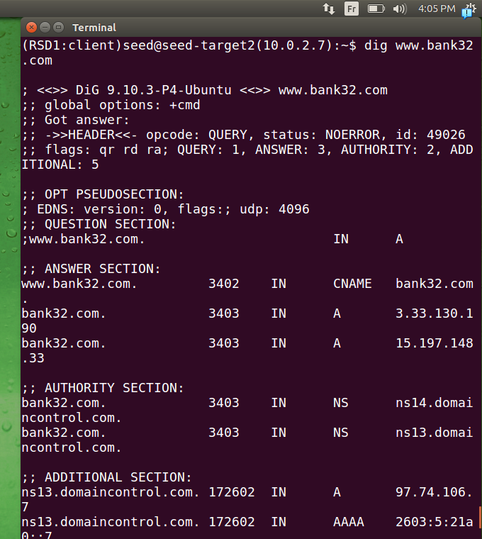
.

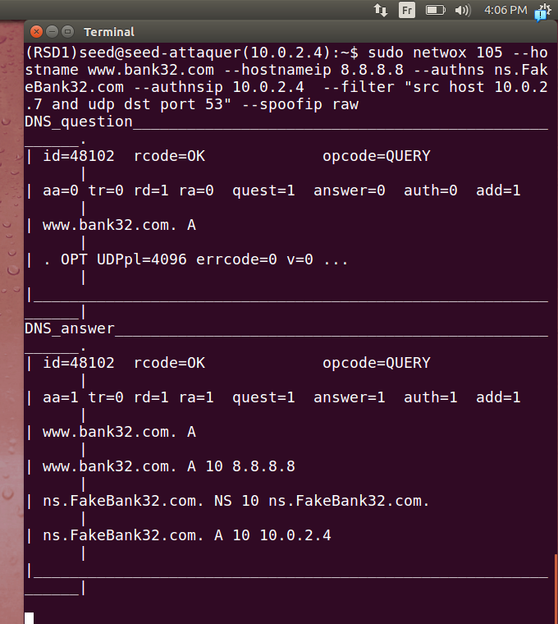
.
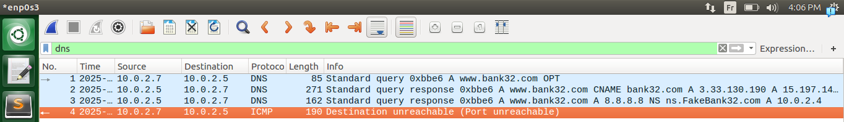
.
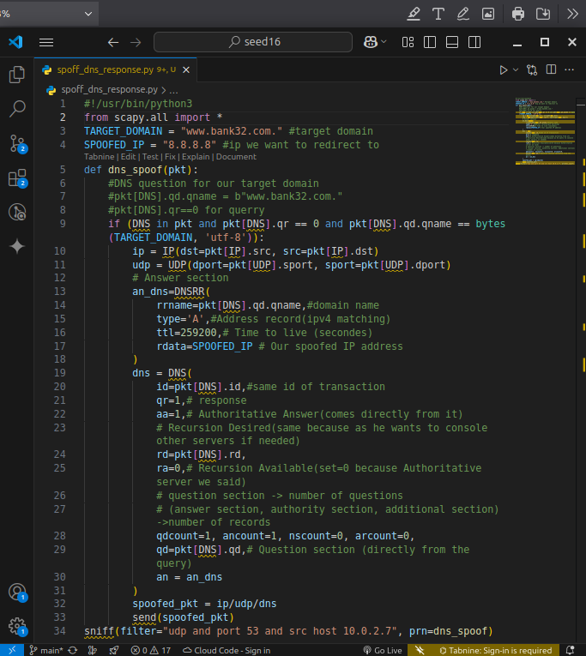

.
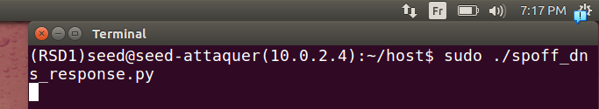
.
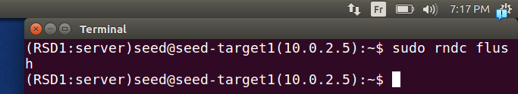
.
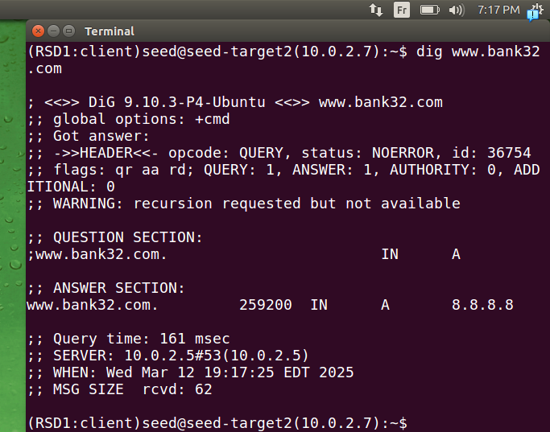
.
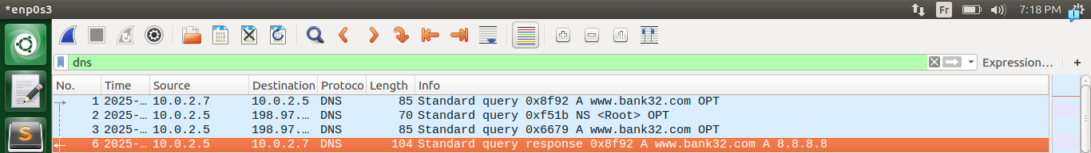
.

Task 6: DNS Cache Poisoning Attack
.
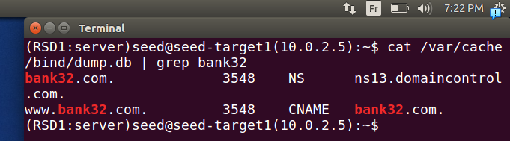
.
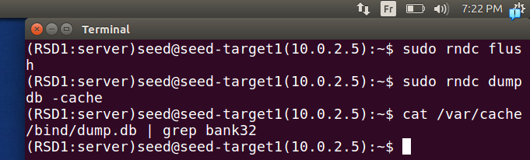
.
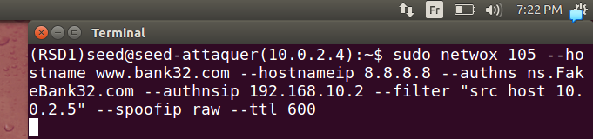
.
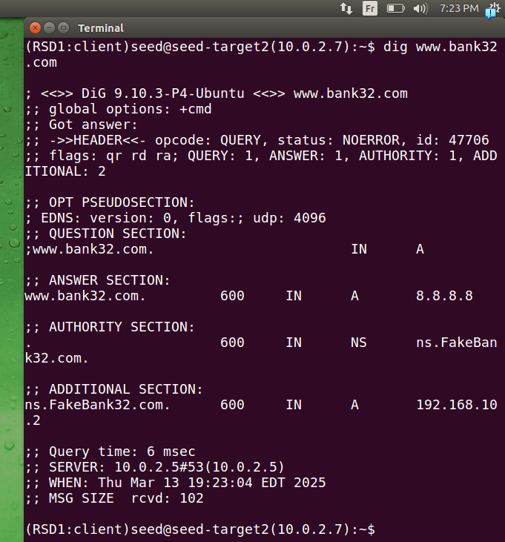
.

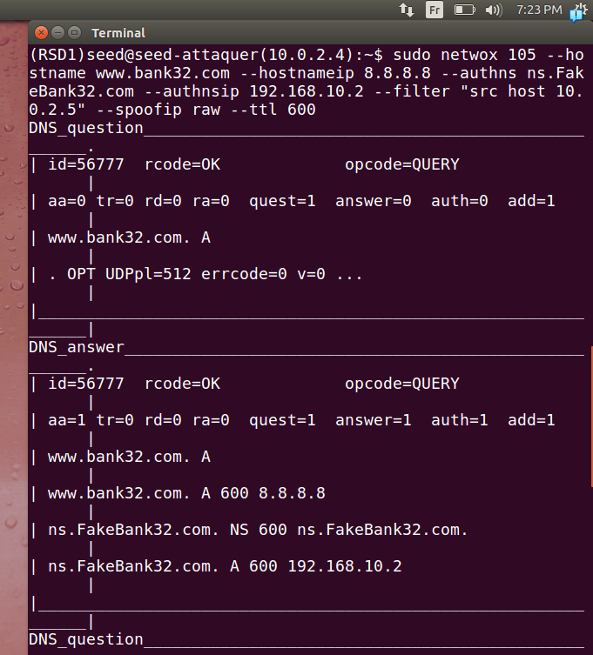
.

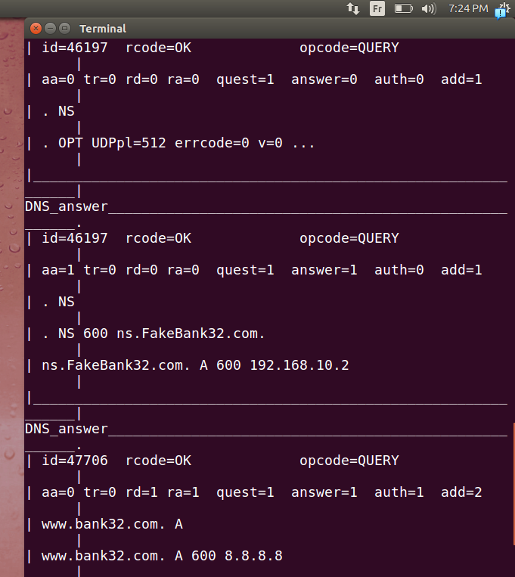
.
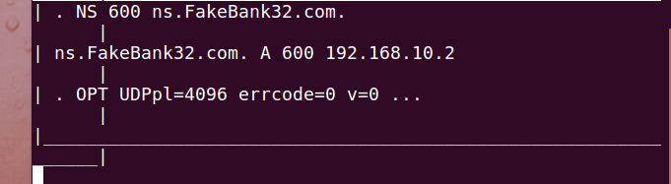

.
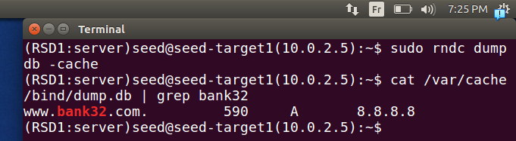
.
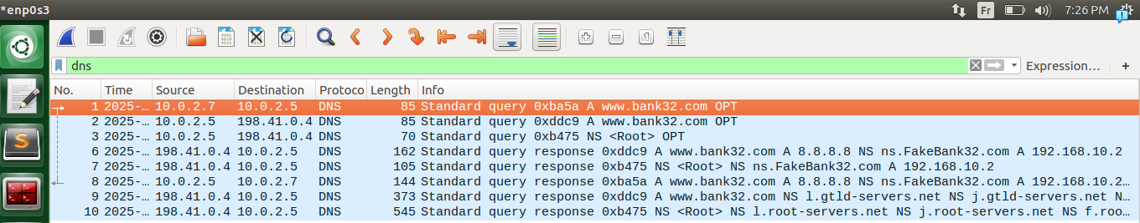
.
.
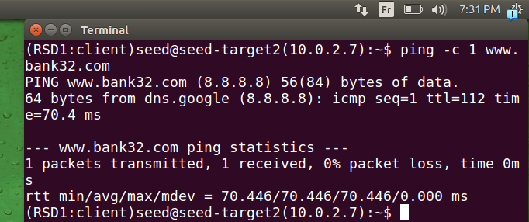
.

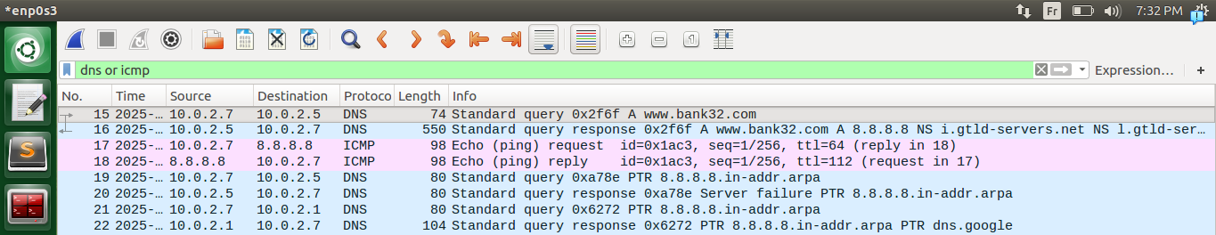
.
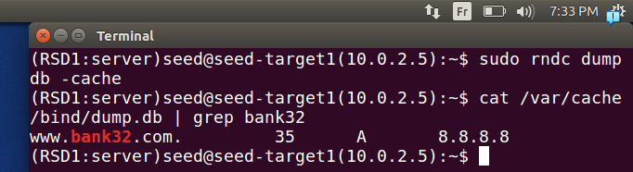
.
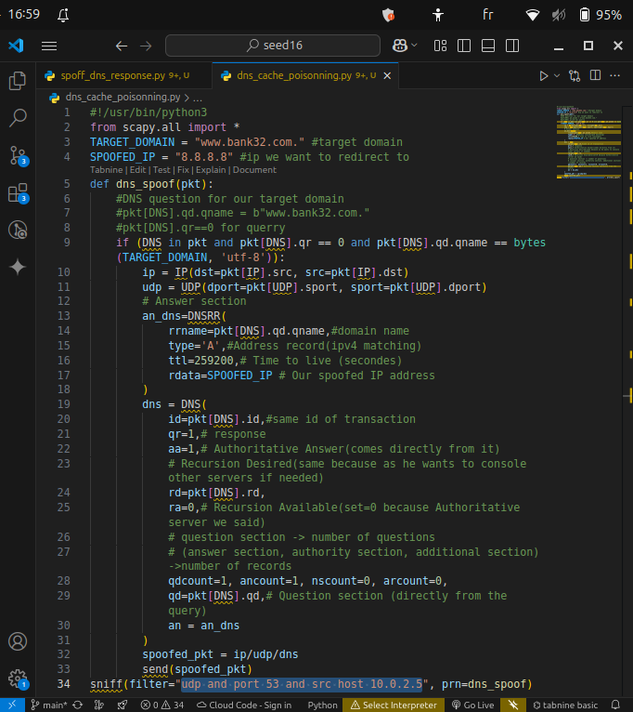
.
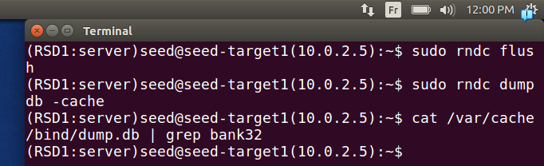
.
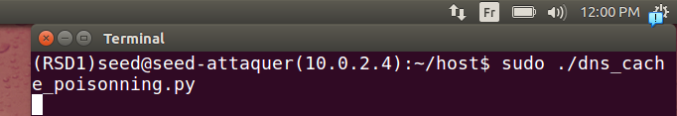
.
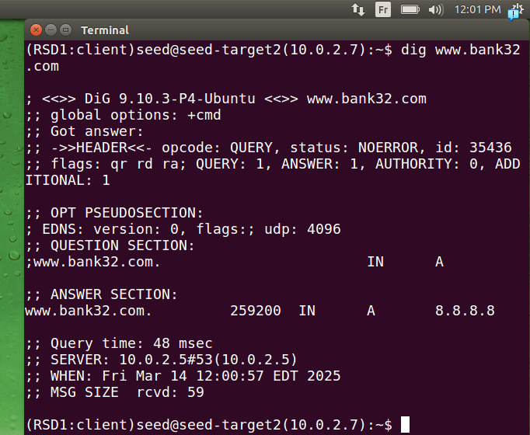
.
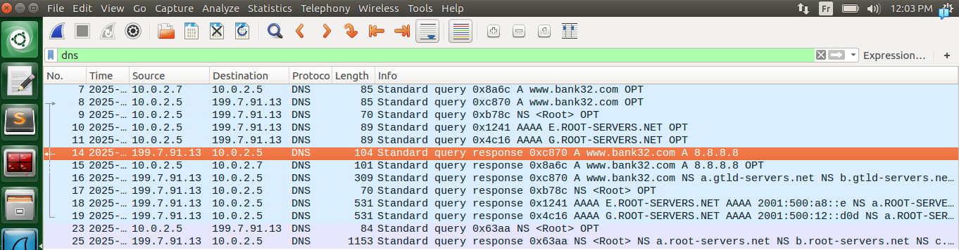
.

Task 7: DNS Cache Poisoning: Targeting the Authority Section
.
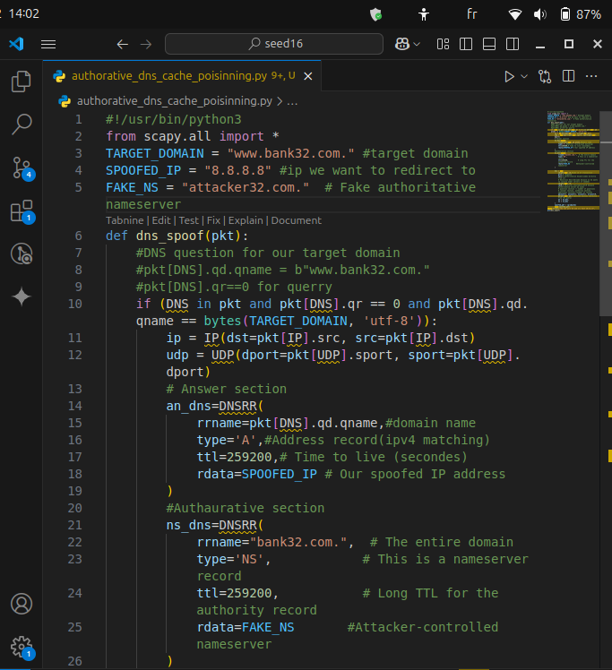
.
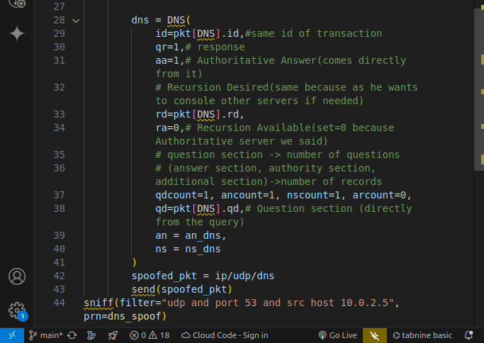
.
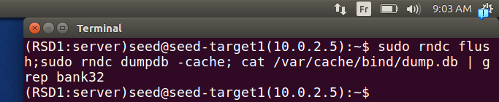
.
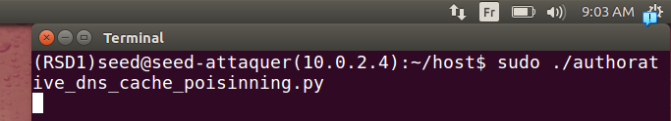
.

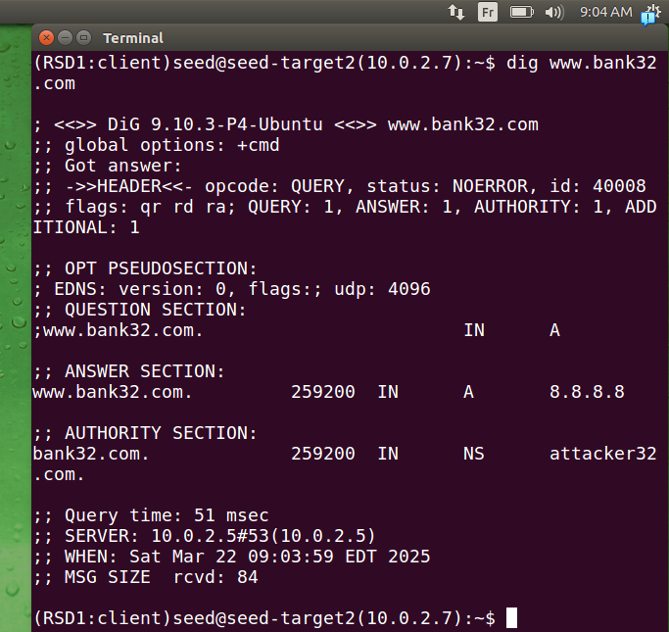
.
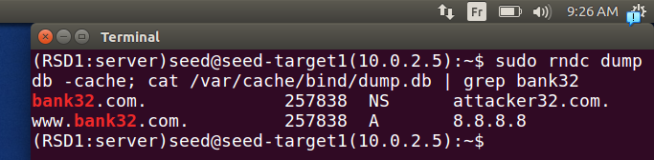
.

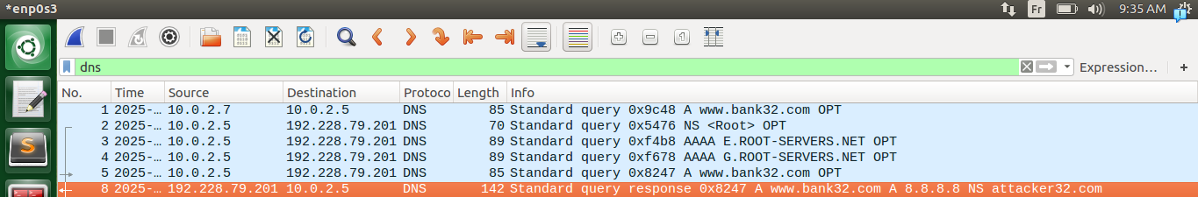
.
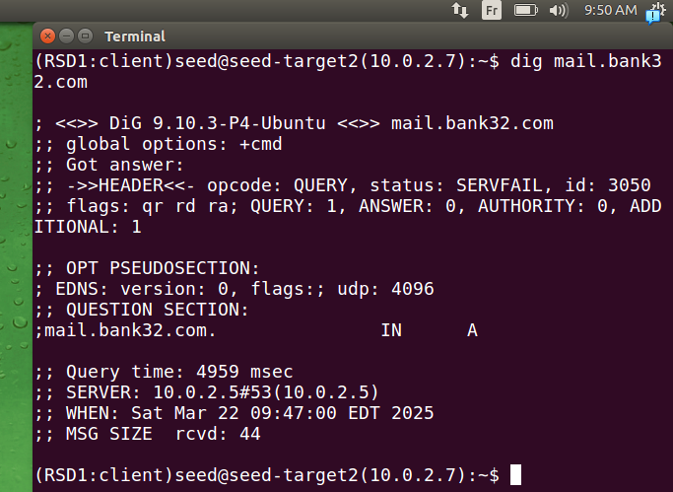
.
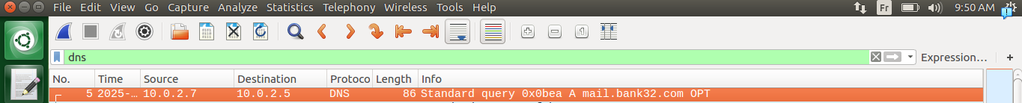
.
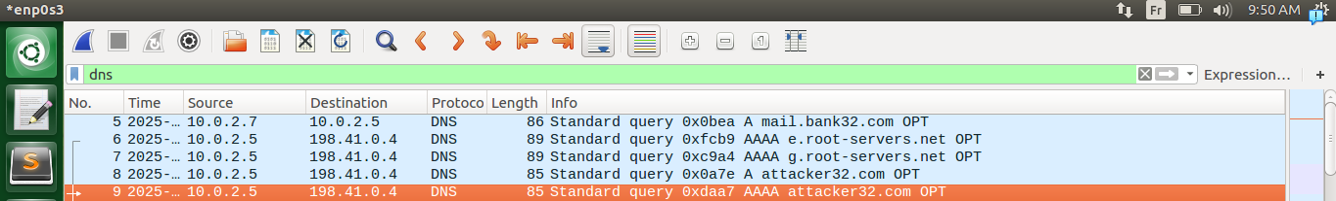
.
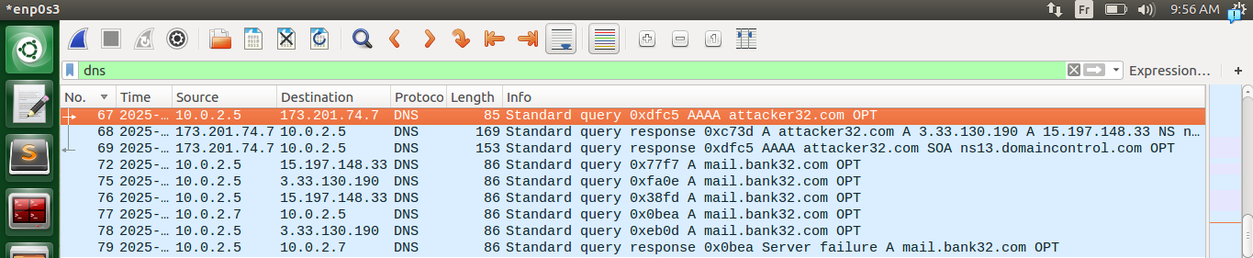
.

Task 8: Targeting Another Domain
.
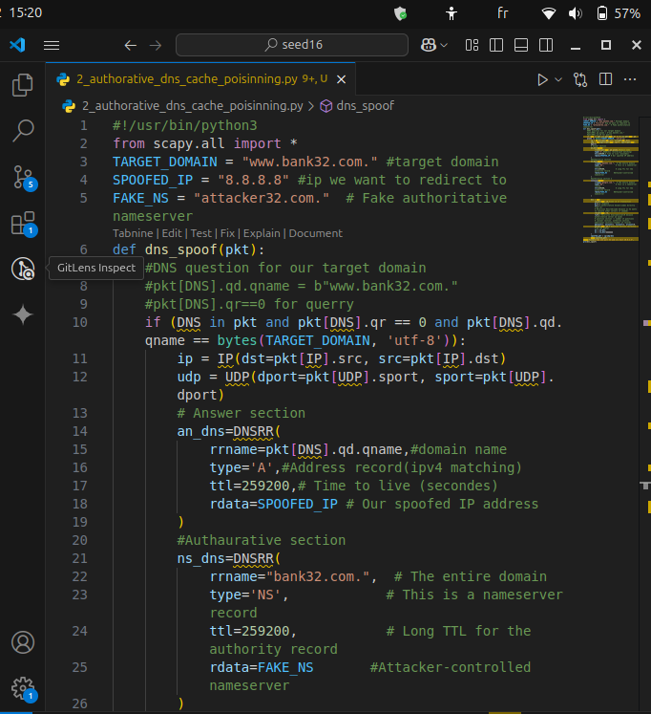
.
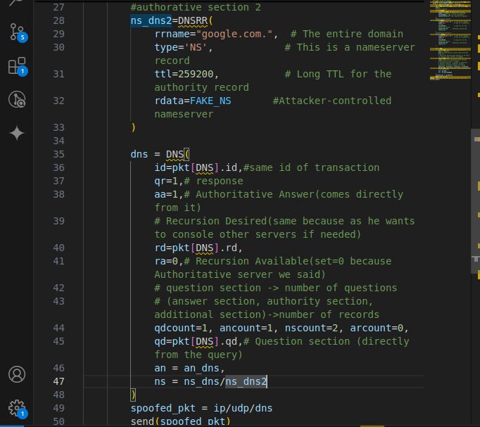
.
.
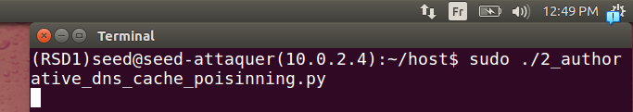
.

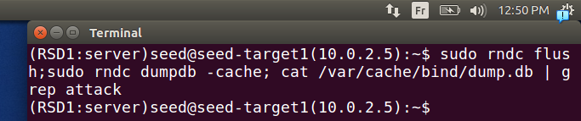
.
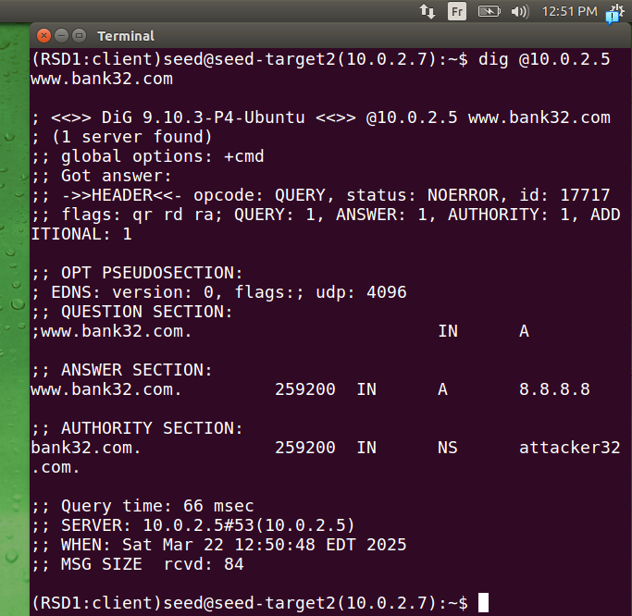
.
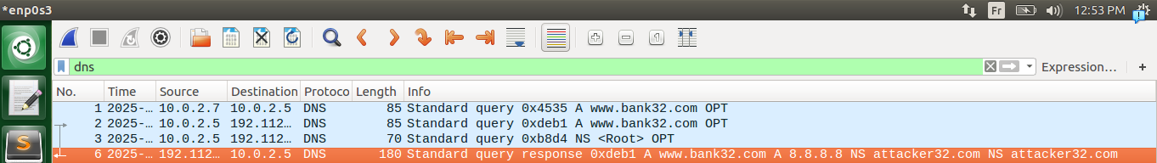
.
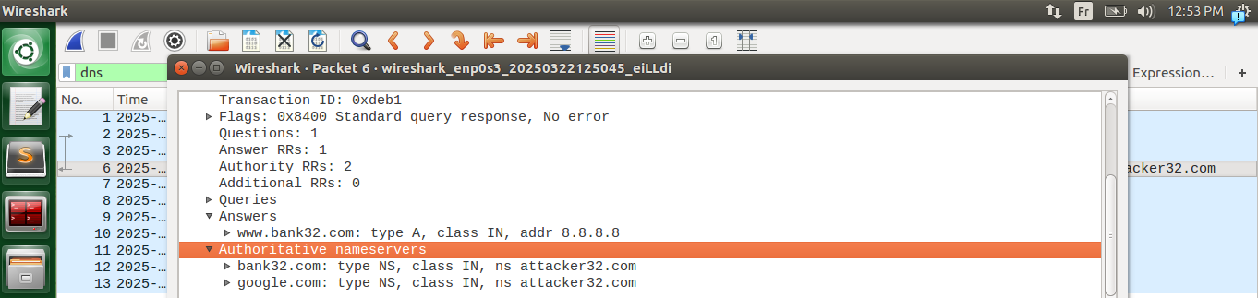
.
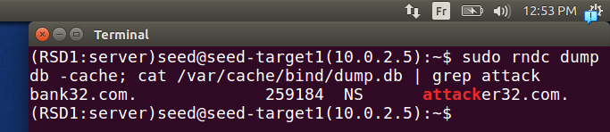
.
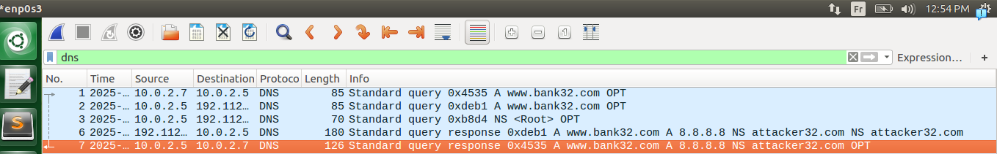
.
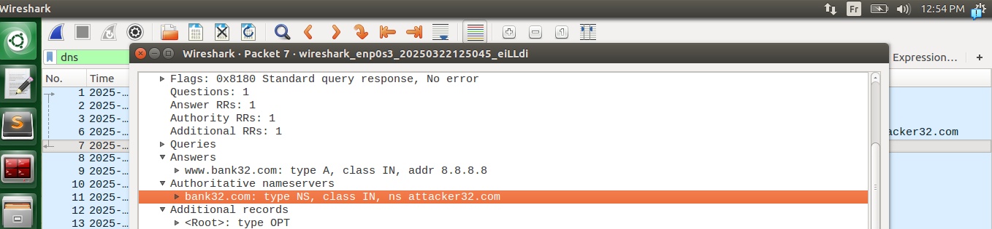
.

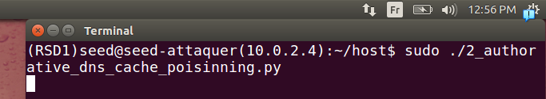

.
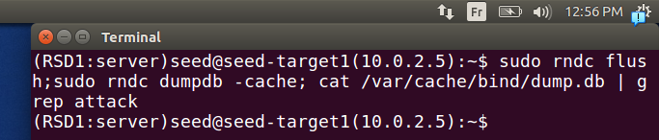
.

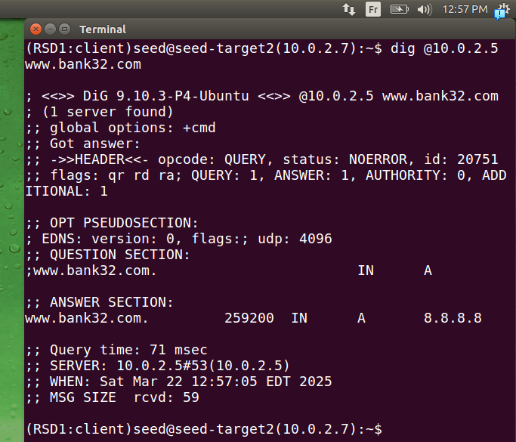
.
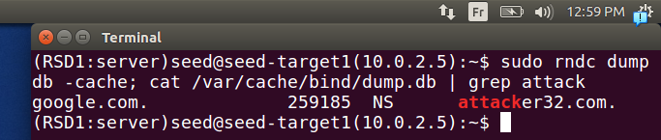
.
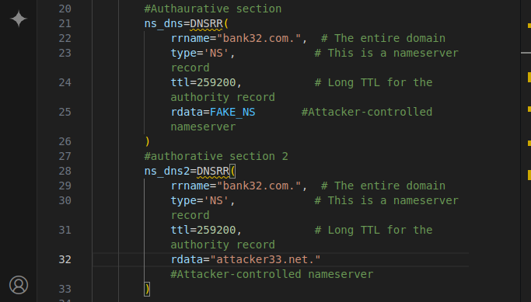
.
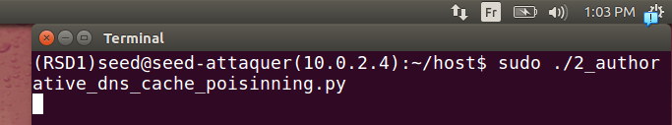
.
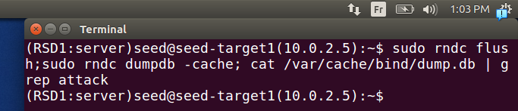
.
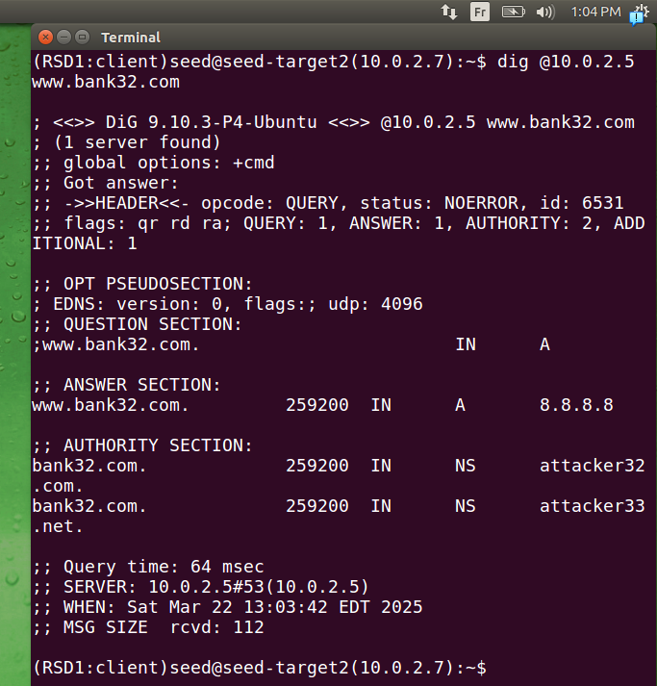
.
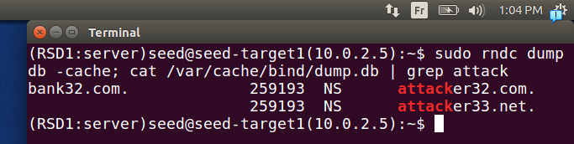
.
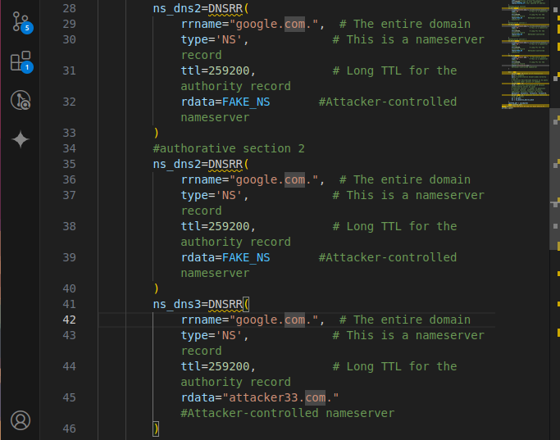

.
.
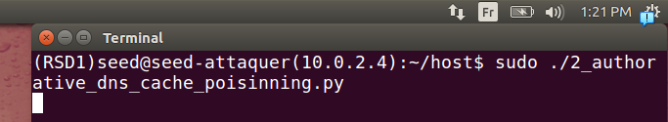
.
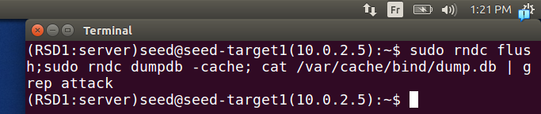

.
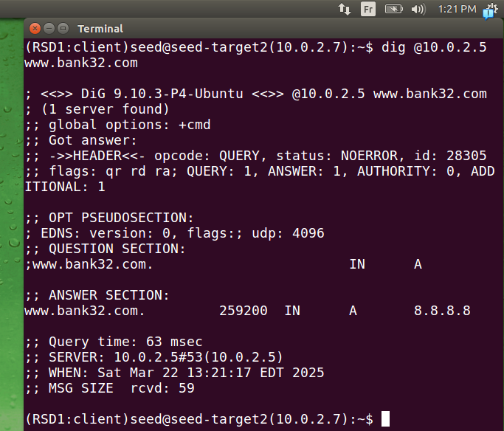
.
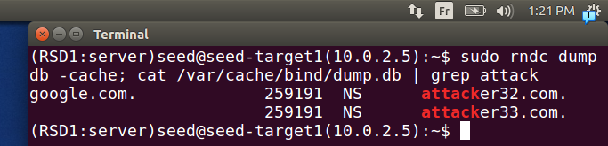
.

Task 9: Targeting the Additional Section
.



